**Supplementary Protocol 1**

Tutorial videos for histo-cytometry analysis with this protocol are available here: https://www.youtube.com/channel/UCvHIV4KcB83j_oB5rbHA65w

The Basics

Flowchart of the histo-cytometry workflow 1

Required Buffers/Reagents 2-3

Computer Requirements 4

Software Installation 5-6

Cell Labeling 7

Tissue Preparation 8-9

Staining Sections 9-10

Imaging with the Confocal Microscope 11-13

3D Image Analysis 13-16

Movie Analysis 17-18

Leica SP5 Confocal Microscope Settings 19

Example Confocal Microscopy Staining Panels 20

Example Epi-fluorescence Microscopy Staining Panels 21

Tips and Tricks

Color options22

Optimal dendritic cell segmentation 22

Batching Xtensions 22-23

Editing Xtensions 23

Spectral Unmixing 23

Using Sortomato 24

Distance Transformation 24-25

Exporting Statistics 25

Documentation

Generate Compensation Matrix 26

Chrysalis 27-33

Sortomato V2.0 34-37

XTChrysalis/XTChrysalisImaris9 38-40

XTCreateSurfaces 41-42

XTStatisticsExport 43-44

Adding 0.1 to CSV files (addValueToAll_CSV.py) 45

Alternatives to Chrysalis 46

XTChrysalis2phtn 47-49

XTMovieSurfacesAndStats 50-52

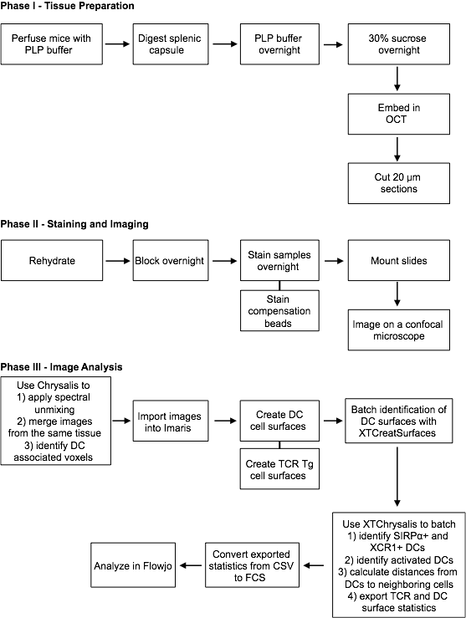

**Required buffers/Reagents:**

● 4% Paraformaledehye (PFA), diluted in PBS from 20% PFA (Electron Microscopy Sciences catalog # 15713).

● 1X Phosphate Buffered Saline (PBS) without Calcium Chloride or Magnesium Chloride, pH 7.4 (ThermoFisher Scientific catalog # 14190136).

● 0.2 M L-Lysine (MW: 182.6) in PBS), pH 7.4 (36.52 g/L, Sigma catalog # L5626, store 0.2 M solution in -20˚C, sterile).

● 30% Sucrose in PBS (w/v) (300g/L, Sigma-Aldrich catalog # S0389, store sucrose solution at room temperature, sterile).

● 20X Dispase (16 mg/mL, Invitrogen catalog # 17105-041, store in -20˚C).

● 200X Collagenase P (40 mg/mL, Roche catalog # 11249002001, store in -20˚C).

● Prolong Diamond mountant (ThermoFisher Scientific catalog # P36961).

● Ultracomp eBeads (ThermoFisher Scientific catalog # 01-2222-42).

● OCT embedding medium (Electron Microscopy Sciences catalog # 6255001).

● Super Pap Pen (ThermoFisher Scientific catalog # 008899).

● Fc receptor blocking antibody (BioXCell catalog # CUS-HB-197, clone 2.4G2).

● Fisherbrand Superfrost Plus Microscope slides (Fisher Scientific catalog # 12-550-15).

PLP Buffer:

Prepare buffer just before use (must be used within 1 day)

4% PFA 12.5 mL 6.25 mL 2.5 mL

NaIO4 (sodium periodate) 0.106 g 0.053 g 0.0212 g

L-Lysine 18.75 mL 9.4 mL 3.75 mL

PBS 18.75 mL 9.4 mL 3.75 mL

------------ ----------- ------------

Total 50 mL 25 mL 10 mL

Blocking Buffer:

5% Bovine Serum Albumin (BSA) in PBS 4500 μL

1 M Tris-HCl pH 7.4 500 μL

Fc receptor blocking antibody (clone 2.4G2) 50 μL

Triton-X (after adding, vortex to dissolve) 15 μl

-------------

Total 5000 μL

**Computer Requirements:**

Recommended computer specifications:

Refer to <http://www.bitplane.com/systemrequirements.aspx> for computer specifications.

Required Software:

● Flowjo License

● Imaris license, including the XT module

Requirements for running Chrysalis:

● The matlab files for Chrysalis are available at https://histo-cytometry.github.io/Chrysalis/.

● If running Chrysalis through Matlab, then Matlab 2014b or later needs to be used.

● Chrysalis can be run on Windows, Mac, or Linux operating systems. Compiled versions for Windows and Mac operating systems (do not require a full Matlab license to run) are available at <https://histo-cytometry.github.io/Chrysalis/>. For a compiled Linux version please contact the corresponding author.

Requirements for Imaris analysis:

● Imaris Xtensions are available at https://histo-cytometry.github.io/Chrysalis/.

● Sortomato requires Matlab 2010b to be installed and set as the default Matlab used by Imaris. Sortomato is not compatible with newer versions of Matlab.

● XTChrysalis and XTChrysalis2phtn work with Imaris 8. XTChrysalisImaris9 is compatible with Imaris 9 and XTChrysalis2phtn’s compatibility with Imaris 9 has not been tested.

**Software Installation:**

The Xtensions used in this protocol do not work in more recent version of Matlab than Matlab 2010. Therefore, when installing Imaris it is essential that only Matlab 2010 is installed. If more recent versions of Matlab are installed then Imaris will default to using the more recent versions. If Imaris is already installed on the computer then it is required that Matlab versions more recent than 2010 are uninstalled prior to running the XTensions utilized by this protocol.

Make sure that all possible memory is allocated to Matlab by changing settings for java heap memory (In Matlab, click Preferences then Matlab then General and then Java Heap Memory).

Installing Chrysalis:

Download the compiled Chrysalis at <https://histo-cytometry.github.io/Chrysalis/>.

Installing Sortomato:

1. Download the entire “Sortomato V2.0” folder (including the private folder contained within the Sortomato folder), which is located in the “Chrysalis Imaris Xtensions” folder available at https://histo-cytometry.github.io/Chrysalis/.
2. Place all of .m and .mat files contained in the Sortomato V2 folder but not the private folder into the Matlab folder for the version of Imaris that will be used with Sortomato. For example, if using Imaris 8.4.2 then place the files in C:/Program Files/Bitplane/Imaris 8.4.2/XT/Matlab. This Matlab folder also contains a folder named Private.
3. Place all of the files from the private folder found in the Sortomato V2 folder into the private folder found in the Matlab folder (e.g. C:/Program Files/Bitplane/Imaris 8.4.2/XT/Matlab/private).

Installing the Batchable Xtensions (e.g. XTChrysalis):

1. Download the Batch Process Function Xtension (<http://open.bitplane.com/tabid/235/Default.aspx?id=73>), create a folder named Batch Process in C:/Program Files/Bitplane, and then place the BatchProcess.m file into the new Batch Process folder.
2. Download the chrysalis.properties file and all of the .m files that are in the “Chrysalis Imaris Xtensions” folder but not in the “Sortomato V2.0” folder from <https://histo-cytometry.github.io/Chrysalis/>.
3. Place the chrysalis.properties and .m files into the new Batch Process folder (C:/Program Files/Bitplane/Batch Process).
4. Download xtgetstats.m and xtgetsporfaces.m from the private folder located in the “Sortomato V2.0” folder from <https://histo-cytometry.github.io/Chrysalis/>.
5. Make a new folder named private in the Batch Process folder and place the xtgetstats.m and xtgetsporfaces.m into that folder (C:/Program Files/Bitplane/Batch Process/private).
6. Create a new folder where the images processed by the Imaris Xtensions will be saved (e.g. b:/XtensionsOutput) and then edit the chrysalis.properties file so that the first line is changed from “outputPath = g:/BitplaneBatchOutput” to the file path for the new output folder (“outputPath = b:/XtensionsOutput”).

Required:

Make sure the Matlab and Batch Process folders are added in the preferences of Imaris (http://www.bitplane.com/learning/integrate-a-xtension-downloaded-from-the-imaris-open-page-within-imaris-tutorial).

**Cell Labeling:**

This is a protocol for staining cells for two-photon microscopy. If staining cells for confocal microscopy, use half of the stated Cell Trace Violet concentration for 15 minutes of staining at 37˚C.

Protocol for two-photon microscopy using Cell Trace Violet (CTV; Use ¼ of the CTV for FACS):

1. Resuspend cells in 10% Fetal Bovine Serum (FBS; in PBS) at 10e6 cells/mL
2. Reconstitute a vial of CTV with 20 μL DMSO (5 mM final concentration)
3. Prepare a CTV mixture by adding 3.33 μL of CTV (DMSO) in 1 mL of PBS
4. Add CTV mixture to cells at a 1:1 ratio by volume
5. Incubate cells at 37˚C for 15-30 min (longer staining = brighter/less viability)

Protocol for two-photon microscopy using Cell Tracker Orange (CTO):

1. Resuspend cells in 1% FBS (DMEM) at 40e6 cells/mL
2. Prepare a CTO mixture by diluting 10 mM CTO at 1:1000 in 1% FBS (DMEM)
3. Add CTO mixture to cells at a 1:1 ratio by volume
4. Incubate cells at 37˚C for 20-30 min (longer staining = brighter/less viability)

**Tissue Preparation:**

1. Sacrifice mice one at a time with CO2.
   1. Start harvesting the mice soon after they have stopped breathing (30 to 45 seconds).
   2. Try to limit bleeding when exposing the heart.
   3. Use a peristaltic pump, like the Gilson Minipuls 2, to pump 10 mL of cold PLP buffer into the mouse by inserting the needle into the left ventricle, turning on the pump, and then cutting the right atria. Set the pump speed to 4-5 mL / minute.  
      Alternative (if peristaltic pump is not available): Cut the right atria of the heart and clamp a 25 gauge needle attached to a 12 mL syringe filled with PLP buffer into the left ventricle of the heart.
   4. Perfuse mice with at least 10 mLs of PLP buffer. A good perfusion is indicated by liver blanching, curling of the tail, and sticking out of the feet.
2. Clean tissue of any fat and other debris. Limit handling of the organ.
3. If working with spleen, properly digest the splenic capsule for proper sucrose penetration and OCT embedding.
   1. Digest with Collagenase P (1:200) and Dispase (1:20) in RPMI (no FBS) for 7.5 minutes at 37˚C.
4. Incubate at 4˚C overnight in PLP buffer. Alternatively, use a 1% PFA (PBS) solution by diluting BD Cytofix/Cytoperm, which is 4% PFA, to 1% PFA (PBS). The 1% PFA without all the other PLP buffer components works with most antibodies.
5. Wash the tissue two times in PBS by incubating tissue in PBS at room temperature for 5 minutes for each wash.
6. Incubate at 4˚C overnight in 30% sucrose (PBS).
7. Embed the tissue in OCT.
   1. Allow the tissue and OCT to equilibrate at room temperature before freezing so they do not separate when the tissue is cut.
   2. Helpful tip: If embedding multiples spleens in one block that are different (like a time course) put a bit of liver on one end to know which spleens is which.
8. Store the frozen tissue at -80˚C.
9. For imaging with a confocal microscope, cut 20 μm sections of the OCT frozen tissue onto superfrost plus slides using a cryostat. For imaging with an epi-fluorescence microscope, cut 7 μm sections of the OCT frozen tissue onto superfrost plus slides using a cryostat.
   1. Helpful tip: If a bit of liver was embedded alongside the spleens, it is best to cut off the OCT portion with the liver to make the block a bit smaller to be able to fit two sections per slide.

**Staining Sections:**

1. Optional: If imaging on the epi-fluorescence microscope (avoid this step if imaging on the confocal microscope), dehydrate the tissue with 100% acetone for 10 minutes at -20˚C.
2. Draw lines on the edges of the tissue sections with a PAP pen and let it dry.
3. Rehydrate tissues for 10 min with 0.1 M Tris-HCl (PBS), pH 7.4.
4. If staining for phospho STATs, incubate tissues in 100% methanol for 30 min at -20˚C.
5. Block sections at 4˚C overnight with Fc receptor blocking antibody in 0.3% Triton, 5% BSA (PBS). Blocking for an hour at room temperature is acceptable for 7 μm sections that will be imaged with the epi-fluorescence microscope.
6. If using sytox nuclear stain, aspirate blocking buffer off necessary samples, add 100ul TE buffer, wash with TE (5 min incubation at room temperature), and then add the nuclear stain diluted in TE buffer (sytox green is used at 1:80,000) and let incubate for 5 min at room temperature before washing with PBS (5 min incubation at room temperature).
7. Spin antibodies down at a high speed for a short period of time before using for staining to avoid any aggregates.
8. Stain with directly conjugated antibodies in blocking buffer but without Fc receptor blocking antibody overnight at 4˚C or for 3 hrs at room temperature. Staining for an hour at room temperature is acceptable for 7 μm sections that will be imaged with the epi-fluorescence microscope.
   1. Any brilliant violet dyes must be stained overnight or longer because they are too large to efficiently penetrate the tissue.
   2. If staining is dim on sections with multiple tissues, then double the concentration of all of the antibodies.
9. While staining the tissue, prepare the compensation beads and compensation slide (prepare slide next day if doing overnight staining).
   1. Prepare tight circles of approximately 0.75 cm in width with a PAP pen, which will hold each individual comp bead stain.
   2. One slide can accommodate all of the colors for a typical 6 to 10 color experiment.
   3. While the PAP is drying, stain eBioscience Ultracomp eBeads in separate microcentrifuge tubes with 1 drop of beads per tube and 2 (BV421, BV510, and BV480) or 3 (AF647, CF514, AF488 and AF594) or 4 (AF700, eFluor 570, CF405L, and Pacific blue which comps for CTV) μL of antibody overnight at 4˚C or at room temperature for an hour. It is best to use the same antibody for staining the tissue sections and the beads, but substituting for a different antibody in the same color when staining beads will also work.
   4. Wash the beads at 660 rcf for 5 min in 1 mL of PBS followed by carefully pipetting off most of the PBS using a P1000 pipette. Switch to the P200 pipette and remove any leftover excess liquid to get the Ultracomp eBeads concentrated into < 5 μL of PBS.
   5. Pipette up and down to resuspend the beads before transferring the beads over to the slide.
10. Wash the stained slides twice with PBS (5 min incubation at room temperature per wash) before mounting.
11. Mount the experimental and compensation slides with Prolong Diamond. Do not let the Ultracomp eBeads dry out before mounting.
12. Image the samples on a Leica SP5 confocal upright microscope same day or next day (imaging within about 16 hours post mounting is optimal). This is a balance due to needing the mountant firm enough, but also preserving maximum signal from the fluorescent proteins.

**Imaging with the confocal microscope:**

Turning on the microscope:

1. Put 10X and 63X objectives into the collar of the microscope.
2. If the 10X or 63X objective has a corrective collar, then check that the collar is in the optimal position once the microscope is set up and the tissue is identified on the brightfield setting by adjusting the collar while examining the tissue.
3. When imaging for long periods of time, the stage holding the slide may drift downward in the Z direction. To prevent this from occurring, the stage can be locked down by first finding the optimal Z position of the stage and then placing objects below the stage (like tube holder racks) to prevent it from drifting downward over time.
   1. When applying objects underneath the stage, keep in mind that the stage needs to be at a location where all of the focusing on the slide can be done with the lens. Therefore, the blocks need to be large enough to get the stage in range for the lens movement but not so large that it smashes the lens when a slide is put on.
4. Flip the switches from 1 to 6 (leave 7 off unless using the two-photon laser).
5. Make sure turret (objectives) are in a locked position when starting up Leica software or it will give an error message.
6. Do not turn on resonance scanner unless doing two-photon microscopy or if super high scan speeds are needed, such as for tiling an entire spleen cross section.
   1. This is selectable immediately upon opening the Leica software. Also check that the configuration is 4 Ch NDD not 4 Ch NDD 1 Ch TLD, and **not** simulation mode.
7. Click yes to initialize the stage, but make sure lenses are not close to the stage and the stage can move around freely.
8. Once the Leica software starts up, go to configuration and laser. Turn on every laser except MP (unless using the two-photon laser) and set Argon laser to 30%.
9. In Acquire>Acquisition, select Pinhole and bidirectional X.
10. Set the acquisition parameters to 1024 X 1024, 400 Hz speed, and 3X line averaging.
11. Set Z stack to Z-wide instead of z-galvo.
12. For the laser mirror set it to substrate for the 405 laser and the proper dichroic mirror for the lasers being used (either TD 488/543/633 or TD 458/594).
13. When setting up the detector, the detector must be at least 10 nm away from every laser line.
14. Start with the laser strength at 20%. The power on some of the lasers (e.g. the 543 and 594 lasers) may need to be increased based on the appearance of the tissue.
15. When setting up detectors for the tissue, try to keep the detectors at around 75% of maximum, so 300 for HyD and 900 for PMT.
16. Set the offset on the PMT to -0.1% to -0.4% depending on the appearance of the Look-Up Table (LUT) view showing saturation. The background should have sparkles of green and the offset should be set as closely to zero as possible.
17. Select sequential scan and set it to “between frames”.

Tips and instructions for acquiring the images:

● Image primarily with the HyD detector with sequential laser excitement. Use the PMTs alongside the HyD when detecting multiple non-overlapping fluorophores simultaneously to speed up the image acquisition.

● When imaging, scan the tissue for interesting biology with a 10X objective and brightfield to properly focus on the tissue. Then apply the oil and check the position on brightfield with the 63X oil objective (1.4 NA).

● The phase might need to be adjusted when using bidirectional x scanning.

● For 20 µm sections, the images should be around 20-25 µm z-stacks.

● The z-step size should be ½ to ⅓ of the section thickness (Shown in XY panel). The smaller the slice, the better the resolution until about ⅓ of the slice thickness. Use larger z step sizes, like 0.5 µm, if optimal imaging settings are not required. Step size should be set based on what resolution is required for each application. For example, a T cell is approximately 6 µm large so a step size of 3 µm might yield 2 images of a T cell, which would make surface creation for T cell identification less accurate than 12 images of the same T cell generated with a step size of 0.5 µm.

● After setting up the microscope on the tissue, it is necessary to capture images of the ultracomp ebeads for Dye Separation. Try to get the beads at saturation in some spots. Sometimes the tissue looks brighter than the bead even when imaging with the same microscope settings, but it is important to **not** change any microscope settings for only the beads or tissue. Rather, adjust the microscope settings for the best detection of beads and tissues, if possible, and if not then make sure the tissue images look good.

● A way to batch the imaging process is to embed multiple tissues in a single OCT block. Upon imaging the multiple tissues on a single slide, identify the ‘mark and find’ spots across all of the tissues. Be sure to write down which ‘mark and find’ spots are associated with which tissue on the slide. Once the images are captured, make a new folder for each tissue with the proper tissue name in the leica software. Next, select all images that correspond to a single tissue by left clicking the start of the list and then shift+left click on the end of the list. For example, if there are 20 ‘mark and find’ images with images 11-20 corresponding to one tissue then select image 11 then shift+left click on image 20. Once all of the images for a single tissue are selected, then right click on one of the images and select cut. Next, select the new folder for that tissue and right click and select paste.

● If using mark and find or tiling a slide then it is good to tape down the slide to limit it’s movement in the slide holder. Use small pieces of black Gorilla tape to tape the bottom edge of slide to the slide holder on both sides. Do not tape the top of the slide because the slide will be pulled up which will cause drift in the Z plane.

**3D Image Analysis:**

1. **Generate a Compensation Matrix** (pg. 25, Documentation > Generate Compensation Matrix): Generate a compensation matrix with the single color stained beads by using ImageJ to run the Generate Compensation Matrix script.
2. **Use Chrysalis to Process Images** (pg. 26-32, Documentation > Chrysalis): Spectrally unmix, merge, and generate a new channel for cell type 1 (e.g. dendritic cell; DC) and cell type 2 (e.g. T cell receptor transgenic; TCR Tg)-associated voxels with the Chrysalis software.
3. Open images in Imaris and analyze the Chrysalis processed images.
   1. Click the Edit tab and select image properties. In the Geometry section, adjust the voxel X,Y, and Z values to the original values which can be found by examining the Lif file image properties in the Leica LAS software. This step is necessary because image processing in Chrysalis might change the X, Y, and Z values. Typically, voxel size for X, Y, and Z are 0.24, 0.24, and 0.494 for images acquired with the 63X lens on a Leica SP5.
   2. Change the channel name and color, then click okay on the image properties window.
   3. Click fit and reset buttons in the lower right hand corner of Imaris.
   4. Save Imaris periodically because it sometimes crashes, especially for large data files. Save files by clicking “export” under the file tab.
4. Create cell type 1 surfaces based on the DC channel generated in Chrysalis and name it ‘DCs’ surfaces.
   1. During surface creation, separate touching surfaces by selecting segment surfaces with a diameter of 7.5 µm.
   2. This step is batchable through the Arena viewer.
5. Create cell type 2 surfaces based on the channel generated in Chrysalis and name it ‘TCR Tg surfaces’.
   1. During surface creation, separate touching surfaces by selecting segment surfaces with a diameter of 8 µm. Use a smaller diameter if the T cells are not proliferating or a large diameter if the cells are blasting.
   2. This step is batchable through the Arena viewer.
6. **Use Sortomato to Subset Surfaces** (pg. 33-36, Documentation > Sortomato V2.0): Use the Sortomato Xtension on the ‘DCs’ surfaces to identify a subset of interest. In this case, we will be creating regions of activated DCs (CD86+ MHCIIhi) for 2 images (Image 1 and Image 2).
   1. Go to Image 1 in Imaris. Open Sortomato and select the ‘DCs’ surface created in Step 4. Open a 2D plot window in Sortomato.
   2. Select mean intensity for the CD86 channel on one axis and mean intensity for the MHCII channel on the other axis.
   3. Draw a region identifying the activated DCs (CD86+ MHCIIhi). After the region has been selected, press ‘e’ to edit the region name to ‘activated DCs’. Then click ‘s’ to save this region as a matlab file (Image 1.mat). Ensure that the given name for the .mat file is identical to the name for the Imaris file (Image 1.ims).
   4. Go to Image 2 in Imaris. Open Sortomato and select the ‘DCs’ surface created in Step 4. Open a 2D plot window in Sortomato.
   5. Press ‘o’ to open ‘Image 1.mat’. This step applies the region saved in Image 1 (step c) to Image 2.
   6. Move around the region to account for any staining differences between Image 1 and 2, and press ‘s’ to save the Image 2 ‘activated DCs’ region as ‘Image 2.mat’. Again, ensure that the given name for the .mat file is identical to the name for the Imaris file (Image 2.ims).
7. Keep all of the Imaris files (Image 1.ims and Image 2.ims) and the ‘activated DCs’ regions for each file (Image 1.mat and Image 2.mat) in one folder.
8. **Use XTCreateSurfaces to create surfaces from the ‘activated DCs’ regions defined in Step 6** (pg. 40-41, Documentation > XTCreateSurfaces): In Imaris, select the BatchProcess Xtension, select the folder from Step 7, which contains the .ims and .mat files. Then select XTCreateSurfaces.
9. **Use Sortomato to Further Subset Surfaces** (pg. 33-36, Documentation > Sortomato V2.0): Use the Sortomato Xtension on the ‘DCs’ and ‘activated DCs’ surfaces to identify a subset of interest. In this case, we will be creating regions for SIRPɑ and XCR1 DCs for 2 images (Image 1 and Image 2).
   1. In Imaris, go to Image 1 and select the Sortomato Xtension.
   2. Create SIRPɑ and XCR1 DC regions for activated DCs: Select the ‘activated DCs’ surfaces created in Step 8. Open a 2D plot window in Sortomato of the ‘activated DCs’ surfaces. Select mean intensity for the SIRPɑ channel on one axis and mean intensity for the CD8ɑ channel on the other axis. Draw regions identifying the activated SIRPɑ (SIRPɑ+ CD8ɑ-) and XCR1 DCs (SIRPɑ- CD8ɑ+).  
        
      Upon generating a new region for each of the DC subsets, save the regions with the name identical to the Imaris file plus “_roi1” by pressing ‘s’. For example, the two DC regions for Image 1 would be saved as ‘Image 1_roi1.mat’ and it would contain regions for both activated SIRPɑ and XCR1 DCs in a single matlab file.
   3. Create SIRPɑ and XCR1 DC regions for total DCs: Go back to the Sortomato Xtension and select the ‘DCs’ surfaces created in Step 4. Open a 2D plot window in Sortomato of the ‘DCs’ surfaces. Select mean intensity for the SIRPɑ channel on one axis and mean intensity for the CD8ɑ channel on the other axis. Draw regions identifying the SIRPɑ (SIRPɑ+ CD8ɑ-) and XCR1 DCs (SIRPɑ- CD8ɑ+).  
        
      Upon generating a new region for each of the DC subsets, save the regions with the name identical to the Imaris file plus “_roi2” by pressing ‘s’. For example, the two DC regions for Image 1 would be saved as ‘Image 1_roi2.mat’ and it would contain regions for both SIRPɑ and XCR1 DCs in a single matlab file.
   4. Repeat Steps 9a, 9b, and 9c for Image 2. Move around the gates to account for any staining differences between Images 1 and 2. This step would create ‘Image 2_roi1.mat’ and ‘Image 2_roi2.mat’.
   5. Create a new folder containing the Imaris files (Image 1.ims and Image 2.ims) and the regions defined in Step 9 (Image 1_roi1.mat, Image 1_roi2.mat, Image 2_roi1.mat, and Image 2_roi2.mat).
10. **Use XTChrysalis to create surfaces from the ‘SIRPɑ' and ‘XCR1’ regions for activated and total DCs defined in Step 9, calculate distances to these new DC surfaces, and generate a CSV file containing statistics for the TCR Tg T cells and DCs** (pg. 37-39, Documentation > XTChrysalis)**:** In Imaris, select the BatchProcess Xtension, select the folder from Step 7, which contains the .ims and .mat files. Then select XTChrysalis. This step would generate statistics such as intensity mean and minimum for each channel for TCR Tg T cells and DCs. This step would also calculate the distance between TCR Tg T cells and DC subsets.  
      
    **Alternative:** It is possible to combine steps 6-10 by using subgating to subset DCs into activated DCs, as well as subset the activated DCs into SIRPɑ and XCR1 DCs in one step with XTChrysalis. This approach is possible by using the _roi1 and _roi1a nomenclature when naming the saved Sortomato generated regions, as described in the in the “Prior to running this Xtension” section of the XTChrysalis documentation (pg. 37).
11. Analyze data in Flowjo (use version 10.3 or later for proper CSV to FCS conversion built into Flowjo otherwise use the CsvToFcs module of GenePattern (https://genepattern.broadinstitute.org/gp/pages/index.jsf) for converting CSV to Fcs files before loading into Flowjo).

**Movie Analysis:**

1. **Use Chrysalis to Save Movies as AVI files** (pg. 26-32, Documentation > Chrysalis): Save movies as AVI files with Chrysalis to be able to briefly watch each movie to identify movies that depict healthy tissue and are biologically interesting. Keep all of the movie files (the original, non-AVI format versions) that will be analyzed in greater detail in one folder.
2. **Generate a Compensation Matrix** (pg. 25, Tips and Tricks > Spectral Unmixing): Use the Leica Application Suite to generate a compensation matrix (.sdm file) based on one of the movies that will be analyzed or a series of single color control movies.
3. **Use Chrysalis to Process Images** (pg. 26-32, Documentation > Chrysalis): Spectrally unmix, rescale, and generate new channels, if necessary, with the Chrysalis software. Select the Save as Big Data Viewer file feature in Chrysalis so that processed movies are saved for further analysis in Imaris.
4. Open images in Imaris and analyze the Chrysalis processed images.
   1. Click the Edit tab and select image properties. In the Geometry section, adjust the voxel X,Y, and Z values to the original values which can be found by examining the Lif file image properties in the Leica LAS software. This step is necessary because image processing in Chrysalis might change the X, Y, and Z values.
   2. Change the channel name and color, then click okay on the image properties window.
   3. Click fit and reset buttons in the lower right hand corner of Imaris.
   4. Save Imaris periodically because it sometimes crashes, especially for large data files. Save files by clicking “export” under the file tab.
5. Create cell type 1 surfaces (e.g. dendritic cells, DCs) based on one of the movie’s channels and name it ‘DCs’ surfaces.
   1. Select Track surfaces (over time).
   2. Threshold by absolute intensity. For setting the threshold, visually determine the threshold if the automatic threshold appears incorrect.
   3. During surface creation, separate touching surfaces by selecting segment surfaces with a diameter of 10 µm.
   4. Classify seed points by quality. Check the auto settings then visually determine the cutoff.
   5. Threshold based on the minimum number of voxels with a limit of at least 500 (e.g. only include surfaces with over 500 voxels).
   6. Set Max Distance for the Tracking parameter to 14 micron and a max gap size of 3.
   7. Filter by Track duration, selecting only spots with a track duration over 1.5 minutes.
   8. This step is batchable through the Arena viewer.
6. Create cell type 2 surfaces (e.g. T cell receptor transgenic; TCR Tg) based on one of the movie’s channels and name it ‘TCR Tg surfaces’.
   1. Select Track surfaces (over time).
   2. Threshold by absolute intensity. For setting the threshold, visually determine the threshold if the automatic threshold appears incorrect.
   3. During surface creation, separate touching surfaces by selecting segment surfaces with a diameter of 7 µm.
   4. Classify seed points by quality. Check the auto settings then visually determine the cutoff.
   5. Threshold based on the minimum number of voxels with a limit of at least 150 (e.g. only include surfaces with over 150 voxels).
   6. Set Max Distance for the Tracking parameter to 14 micron and a max gap size of 3.
   7. Filter by Track duration, selecting only spots with a track duration over 1.5 minutes.
   8. This step is batchable through the Arena viewer.
7. Keep all of the Imaris files (Image 1.ims and Image 2.ims) in one folder.
8. **Use XTChrysalis2phtn to calculate distances to DC surfaces, calculate cell-cell interactions between DCs and TCR Tg cells, and generate a CSV file containing statistics for the TCR Tg T cells and DCs** (pg. 46-48, Documentation > XTChrysalis2phtn)**:** In Imaris, select the BatchProcess Xtension, select the folder from Step 7, which contains the .ims files. Then select XTChrysalis2phtn. This step would generate statistics such as intensity mean and minimum for each channel for TCR Tg T cells and DCs. This step would also calculate the distance between TCR Tg T cells and DCs as well as interactions between TCR Tg T cells and DCs.
9. Analyze data in Flowjo (use version 10.3 or later for proper CSV to FCS conversion built into Flowjo otherwise use the CsvToFcs module of GenePattern (https://genepattern.broadinstitute.org/gp/pages/index.jsf) for converting CSV to Fcs files before loading into Flowjo).

**Leica SP5 Confocal Microscope Settings:**

Pinhole

Bidirectional X (phase -31.56)

Line Average: 3

Airy 1

4 Sequential Scans

**Scan 1:**

Laser: 405 Power: ~25 Mirror: Substrate

PMT 1 (Yellow): 415-435 Gain: 1100 **BV421**

PMT 2 (Cyan): 455-465 Gain: 880 CTV **Pacific Blue or CTV**

HyD (Magenta): 540-630 Gain: 85 **CF405L**

**Scan 2:**

Mirror: TD 488/543/633

Laser: 488 Power: ~ 18

PMT 1 (Green): 498-533 Gain: 890 **AF488**

Laser: 543 Power: ~20

PMT 2 (Red): 553-595 Gain: 930 **eFluor 570**

Laser: 633 Power: ~ 27

HyD (Blue): 643-680 Gain: 150 **AF647**

PMT 4 (Purple): 705 - 765 Gain: 815 **AF700**

**Scan 3:**

Mirror: TD 458/514/594

Laser: 514 Power: ~10

HyD: 530-560 Gain: 165 **CF514**

**Scan 4:**

Mirror: TD 458/514/594

Laser: 458 Power: ~ 25

HyD (Orange): 468-510 Gain: 280 **BV480**

Laser: 594 Power: ~ 20

PMT 3 (Grey): 604-645 Gain: 970 **AF594**

**Example Confocal Microscopy Staining Panels:**

Panel for basic phenotyping:

F4/80 BV421 (1:200)

B220 Pacific Blue (1:200)

CD8a CF405L (1:100)

pS6 AF488 (1:200)

CD86 CF555 (1:100)

CD45.2 AF647 (1:200)

MHCII AF700 (1:100)

CD11c CF514 (1:300)

CD3 BV480 (1:500)

SIRPɑ AF594 (1:100)

Panel for T cell proliferation:

F4/80 BV421 (1:200)

CTV

CD8a CF405L (1:100)

pS6 AF488 (1:200)

B220 eFluor 570 (1:100)

CD45.2 AF647 (1:200)

MHCII AF700 (1:100)

CD11c CF514 (1:300)

CD3 BV480 (1:500)

SIRPɑ AF594 (1:100)

Panel for Transcription Factors:

F4/80 BV421 (1:200)

B220 Pacific Blue (1:200)

CD8a CF405L (1:100)

CD45.2 AF488 (1:200)

Foxp3 eFluor 570 (1:100)

T-bet or Bcl-6 AF647 (1:100 or 1:20, respectively)

MHC II AF700 (1:100)

CD11c CF514 (1:300)

CD3 BV480 (1:500)

SIRPɑ AF594 (1:100)

**Example Epi-fluorescence Microscopy Staining Panels:**

Panel for basic phenotyping:

CD45.2 AF647 (1:200)

B220 AF488 (1:200)

F4/80 BV421 (1:200)

CD4 AF594 (1:200)

Comprehensive Phenotyping Panel:

DAPI

CD4 BV480 (1:5000)

pS6 AF488 (1:200)

F4/80 eFluor 570 (1:200)

B220 AF594 (1:200)

CD45.2 AF647 (1:200)

Foxp3 AF700 (1:50)

**Tips and Tricks**

**Color options:**

● Approximate Color Brightness of the following fluorophores on the SP5 (Brightest to Dimmest):

CF514, AF488, AF647, AF594, eFluor 570, eFluor 506, Pacific Blue, CF405L, AF700

● It is recommended to use eFluor 506 rather than BV510 or CF405L (BV480 is not recommended in this panel). If BV480 must be used, CF405L works better than BV510 and eFluor 506 in terms of compensation. It is important to titrate CF405L and BV480 linked antibodies when using them together to find optimal staining conditions because BV480 is brighter than CF405L and will need to be more dilute.

● Avoid tandem dyes like any BV dyes with the exception of BV421, BV510, and BV480.

● BV dyes (BV421, BV510, and BV480) are very bright but relatively large so they penetrate poorly and therefore stain poorly for thicker sections like 20 µm sections. They also require longer than an overnight incubation for optimal staining.

● Blocking endogenous biotin can be challenging, which leads to a lot of background signal (especially in macrophages) when using streptavidin conjugated secondaries. It is best to avoid using biotinylated antibodies when possible. In cases where biotinylated antibodies are used, it is important to have the no primary biotinylated antibody added control.

● Spectra for fluorescent proteins and dyes can be quickly examined at https://www.fpbase.org/.

**Optimal dendritic cell segmentation:**

It can be challenging to properly segment DCs due to their morphology, especially their dendrites, and their close proximity to each other. Therefore, over-segmentation of DCs by using a smaller diameter (e.g. 7.5 µm) instead of their actual size (10-15 µm) is advised. This approach is recommended because it is easier to fuse two surfaces together than it is to separate a surface into two in Imaris.

**Batching Xtensions:**

When using the BatchProcess Xtension to a apply an Xtension to a group of Imaris files, put all of the Imaris files to be batched plus any additional required files (e.g. saved Sortomato region files) together in a folder. Open Imaris and go to the Surpass view. Do not open any Imaris files. Select the Xtensions tab, select BatchProcess, select the folder of interest (containing the files to be batched), then select the Xtension to be batched. Imaris might crash if the first file to be batched is already open prior to initiating the batching process. Imaris may attempt to open the file again, which causes the crash. This error is why Imaris should be opened without opening an image prior to running BatchProcess.

**Editing Xtensions:**

Any modified versions of Matlab scripts need to be saved on the desktop because the Matlab files cannot be saved into the C directory. Upon saving the file, added it to the BatchXtension or Imaris’s Matlab folders. Make sure that the modified Xtension has a unique name so that it does not overwrite an already existing file.

**Spectral Unmixing:**

GenerateCompensationMatrix script:

Use ImageJ to run the Generate Compensation Matrix script to create a compensation matrix.

● Run the Generate Compensation Matrix script on a file (e.g. a .lif file) containing separate images for each single color control.

● Each image must only represent one color and not have any contaminants such as Ultracomp ebeads that are stained with other colors.

● It is critical that there is a single color control image for every channel in the tissue that will be spectrally unmixed.

Leica Dye Separation:

Alternatively, use the Leica Dye Separation program that is available in the Leica Application Suite X for spectral unmixing. This can be done by selecting the Channel Dye Separation tool under the “Process” tab. Use images of single color stained beads. When selecting reference points for each color it is important to not select a point that is saturating (no value should be at 255) but it is good to select very bright points for maximal dynamic range. It is useful to change the size of the reference point or go to clusters or edges of beads for defining the best reference points. It is also important to go in order of dyes in relation to the channel. For example, if Channel 1 is BV421 then the first reference point that is marked should be the BV421 stained comp bead. Make sure to have a reference point for every color in the image of the tissue or the tissue image will lose channels when the matrix is applied. Once each reference point is set, save the matrix for applying the matrix to each image through Chrysalis. This save function is only available on LAS versions 3.1 and later.

**Using Sortomato:**

Sortomato is a really powerful way to analyze images but making new surfaces from regions can take several minutes if there are thousands of surfaces in the region. This slows down the analysis process, especially when making new surfaces from regions for multiple Imaris files. The best way to approach this problem is to batch surface creation from regions with XTCreateSurfaces or XTChrysalis.

When drawing regions in Sortomato, make sure to press ‘e’ after drawing a region to change the name of the region. This makes it easier to keep track of the regions and is critical for using the copy (by pressing ‘c’ or ‘C’, depending on desired function) and paste (by pressing ‘p’ or ‘P’, depending on desired function) functions of Sortomato (read the Sortomato documentation for more information). If “region 1” is pasted into a Sortomato graph that already has a region 1, then both region 1s will be displayed and have the same name. However, because they have the same name, it is not possible to specifically delete just one of the regions. For example, deleting region 1 will delete both regions, but region 1 will still be listed in the region drop down menu.

**Distance Transformation:**

Distance transformation calculates the distance to each cell in a surface and therefore is critical for applications like measuring cell-cell interactions. Follow these instructions if not using the BatchProcess Xtension and XTChrysalis for batching creating new surfaces and Distance Transformation.

After identifying the DC subsets, it is necessary to calculate the distances to the XCR1 and SIRPɑ DC subsets. This can be achieved with the XTDistanceTransformationOutsideSurfaceFirst2surfaces Xtension. Run this Xtension by opening the BatchProcess Xtenison, then select the folder containing all of the Imaris files that need to have distance transformation calculated and then select XTDistanceTransformationOutsideSurfaceFirst2surfaces. To batch distance transformation, each Imaris file needs to be saved with the two DC subsets of interest (e.g. SIRPɑ and XCR1 DCs) as the initial two surfaces in the window on the left hand side of the Imaris screen (object list). The processed files will be saved in C:/Program Files/Bitplane/BatchOutput.

There are two options for applying distance transformation to more or less than 2 surfaces. For batching the first surface in each Imaris file select ‘Distance Transformation outside of surface’. For batching multiple surfaces starting from the last surface and going up in the Imaris object list, edit XTDistanceTransformOutsideObjectForBatchLastNsurfaces by changing the 2 in the “N=2” equation in line 67 to the number of surfaces that need to be distance transformed per Imaris file. The changed XTDistanceTransformOutsideObjectForBatchLastNsurfaces file then needs to be saved on the desktop with a slightly altered name (e.g. XTDistanceTransformOutsideObjectForBatchLast3surfaces) and dragged into

C:/Program Files/Bitplane/BatchXTensions. When running BatchProcess, select the Xtension with the modified name.

**Exporting Statistics:**

The graphs generated in Sortomato can be exported in a variety of file formats including pdfs by clicking a button in the top right hand corner of the 2D plot window. Alternatively, values can be exported by using the XTStatisticsExport Xtension through the BatchProcess Xtension. To use this Xtension, open the BatchProcess Xtension, then select a folder that contains all of the Imaris files that will have their statistics exported. Next, select XTStatisticsExport. The exported statistics will be saved into g:/BitplaneBatchOutput but this output folder can be changed with a slight change in the matlab code as explained in the XTStatisticsExport documentation.

**Documentation**

**Generate Compensation Matrix**

This script is run through FIJI (FIJI is just ImageJ) and is used to generate a compensation matrix from single color control images saved as a .sdm file and a csv file. Additionally, a plot of each dye/single color control image of the spectras is saved as a .png file.

**Prior to Running GenerateCompensationMatrix:**

This script has only been tested on images saved in Leica’s .lif format, however it supports a wide range of other formats like Nikon’s .ND2 format. Every format on this list (<https://docs.openmicroscopy.org/bio-formats/5.5.3/supported-formats.html>) that can have multiple images per file can be used with this script.

1. One file, like a .lif file, must contain all of the single color control images that are in order based on their channel. For example, if BV421 is detected in channel 1, then the BV421 single color control image should be the first image in the .lif file.

2. Each image must only represent one color and not have any contaminants (e.g. Ultracomp ebeads stained with other colors). If necessary, crop the images.

3. There must be a single color control image for every channel that is present in the image of the tissue that will be spectrally unmixed. For example, if the image of the tissue has 10 channels then there should be 10 single color images in the file.

4. FIJI needs to be installed (<http://fiji.sc/#download>) to run this script.

5. FIJI/Bioformats might need to be updated to run this script. Update by using the Update command from the Help menu. Then go to Manage Update sites, tick Bio-Formats, click Close, apply changes and restart Fiji.

**Running GenerateCompensationMatrix:**

1. Start FIJI.

2. In FIJI, open GenerateCompensationMatrix.py

3. Select Run in the Window that appears.

4. In the new GenerateCompensationMatrix window, select the file with the single color control images in the compensation file box.

5. Select the features of interest, like “Save as SDM” and “Save the plot as PNG”.

6. Select run.

7. The script will open each series (single color control image) and calculate a threshold from the maximum intensity projection using the 'triangle' algorithm. It then uses the threshold to calculate the mean intensity above the threshold.

8. The generated files are saved in the same folder that has the file with the single color control images.

**Chrysalis**

This software is for analyzing multispectral 3D images like those acquired on confocal or epi-fluorescence microscopes as well as two-photon multispectral movies.

This software can be run without owning a copy of Matlab by using the compiled version of Chrysalis available at <https://histo-cytometry.github.io/Chrysalis/> (refer to pgs. 5-6 for installation instructions).

For running Chrysalis through Matlab, the computer must have bfmatlab installed.

Installing bfmatlab:

<http://downloads.openmicroscopy.org/bio-formats/5.2.4/>

Go to downloads and select matlab toolbox. When downloaded, unzip and copy bfmatlab folder to C:\Program Files. Make sure line 694 in the matlab code for the Chrysalis.m file reflects the location of the bfmatlab folder [addpath (‘C:\Program Files\bfmatlab’);].

**Running Chrysalis:**

This software has only been tested on images saved in Leica’s .lif format, however it supports a wide range of other formats like .tiff and Nikon’s .ND2 format. A complete list of supported formats is here (https://docs.openmicroscopy.org/bio-formats/5.5.3/supported-formats.html).

1. Put all the image files to be analyzed into one folder.

2. If the images will be spectrally unmixed, then use the GenerateCompensationMatrix script and ImageJ to generate a compensation matrix.

3. Start the software by opening Chrysalis.m. Alternatively, open Chrysalis.exe on Windows computers or Chrysalis on Mac.

4. For running Chrysalis in Matlab: Open Matlab, click the editor tab and then click the run button which will make the Chrysalis window appear.

5. In the Chrysalis window, click the “Input folder” button, select the folder containing the image files to be analyzed, click on the “output folder” button, and then select the folder into which the analyzed files will be saved. If spectrally unmixing the images, then click on the “Compensation Matrix” button and select the .sdm file that contains the compensation matrix for the images that will be analyzed. If the image files to be analyzed are in a format other than .lif then change the text in the “file extension” textbox to image’s file format (e.g. .tiff).

6. Select the file type to be analyzed by selecting either movie or 3D image.

7. Select the type of image processing that will be done on the files by selecting any of the options found under image processing (each option is described in detail in the features section below). Once all of the settings for the image analysis are chosen, click the run button in Chrysalis window (not the matlab window) to start the analysis.

**Chrysalis Window with 3D image analysis selected:**

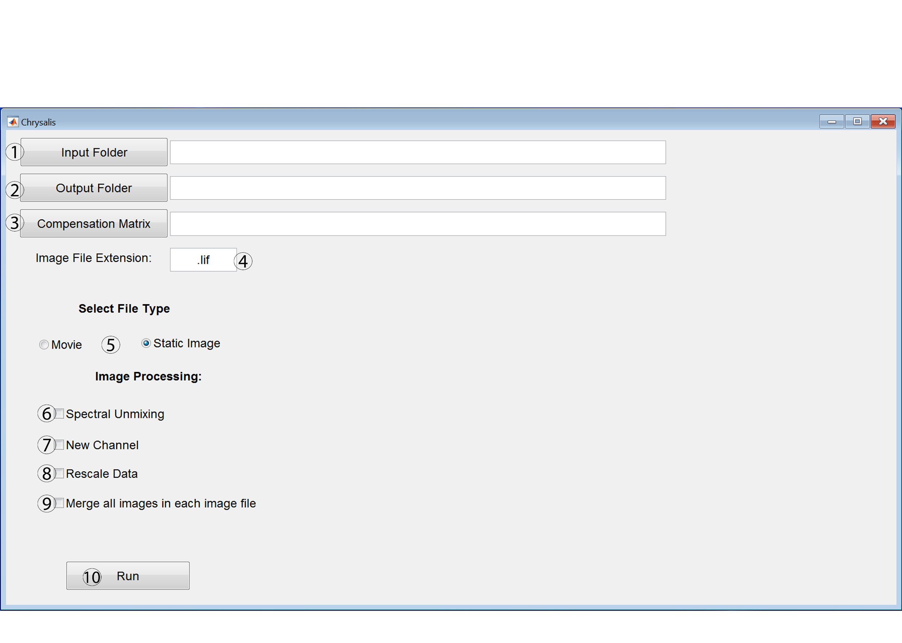

1. Button for selecting the folder that contains the image files that will be processed in Chrysalis. The path for the selected folder will appear in the textbox on the right of the “Input Folder” button and can be edited, if necessary.
2. Button for selecting folder into which image files will be saved after they are processed in Chrysalis. The path for the selected folder will appear in the textbox on the right of the “Output Folder” button and can be edited, if necessary.
3. Button for selecting the compensation matrix file (.sdm file) created with GenerateCompenesationMatrix or Leica Application Suite. The path for the .sdm file will appear in the textbox on the right of the “Compensation Matrix” button and can be edited, if necessary.
4. This textbox states the file extension for the images that will be processed by Chrysalis. The default text is .lif, but this textbox must be edited if a different file format is being used (e.g. if the image files are .ND2 then type “.ND2” in this textbox).
5. Select “Movie” to analyze two-photon microscopy movies or select “Static Image” to analyze 3D images.
6. Select this feature to spectrally unmix images with Chrysalis. This spectral unmixing utilizes the compensation matrix defined by pressing the “Compensation Matrix” button. A compensation matrix must be defined to apply spectral unmixing to images.
7. Select this feature to generate a new channel based on user defined parameters (refer to New Channel Generation in Chrysalis, pg. 28).
8. Select this feature to rescale the data to improve image visualization in Imaris. Selecting this feature is highly recommended.
9. Select this feature to merge every image within an image file (e.g. .lif file) in the z plane. The images will be stacked one after the other.
10. Select this button will process images with Chrysalis based on the parameters selected in this window.

**New Channel Generation in Chrysalis:**

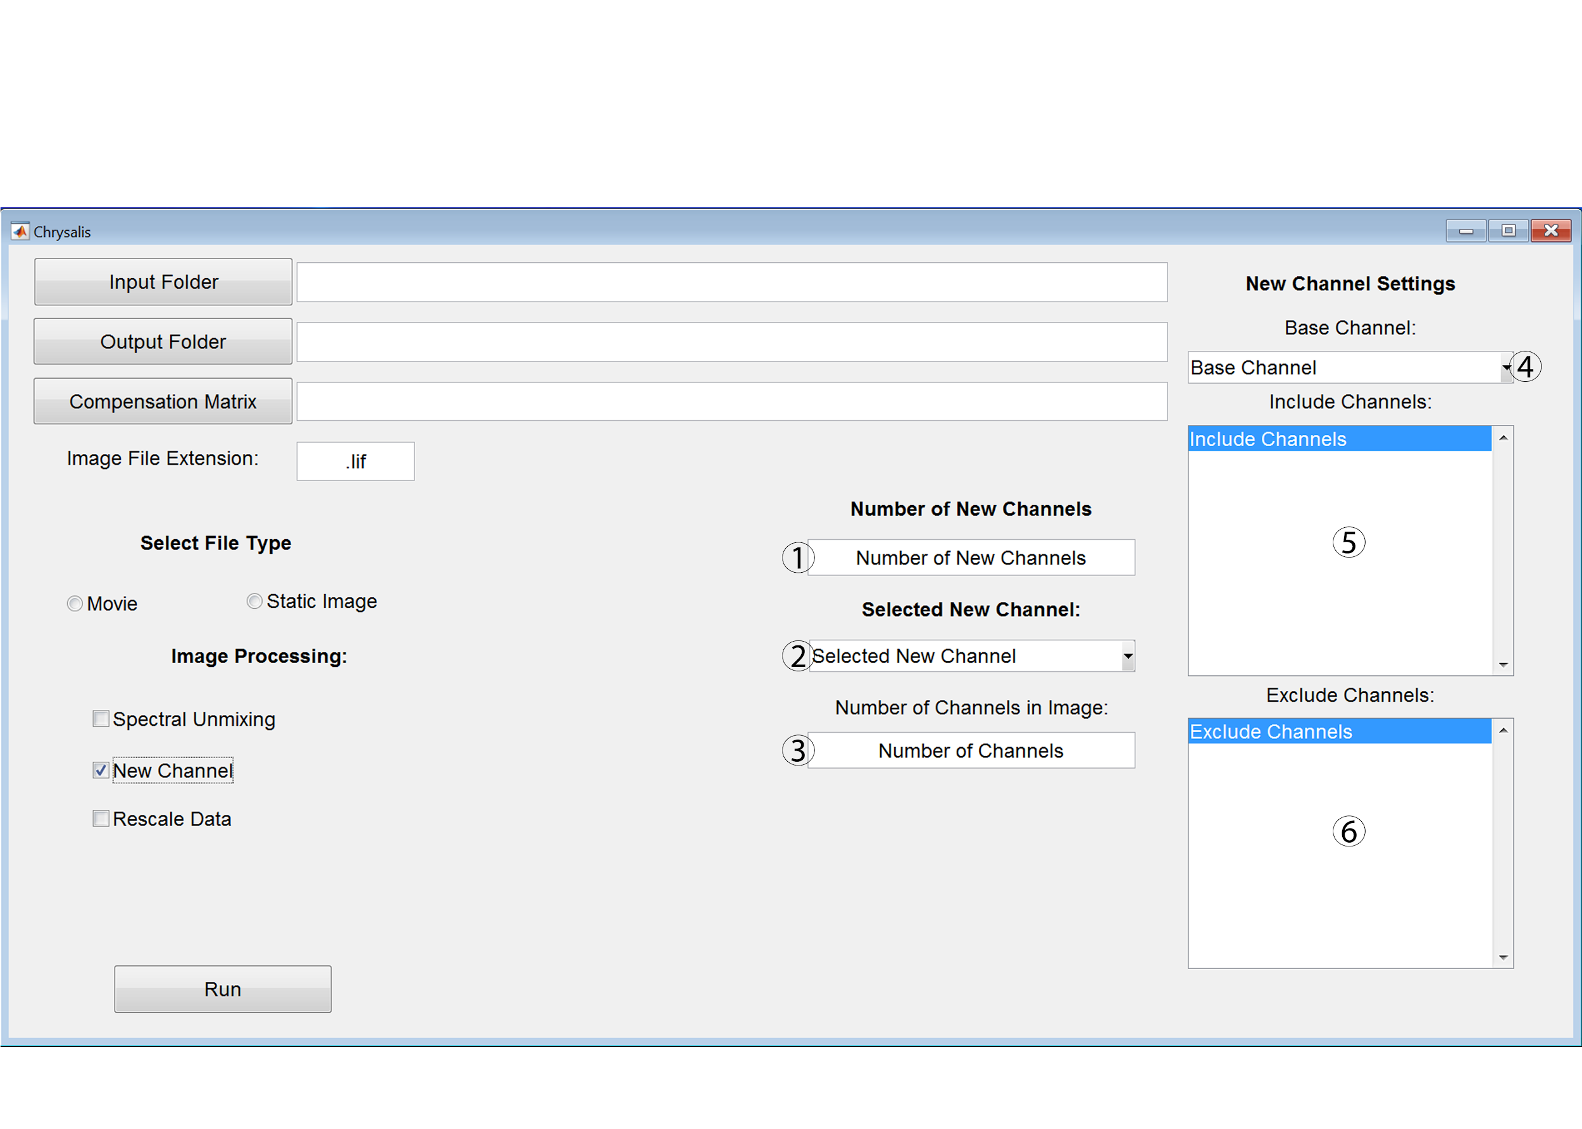

1. In this textbox, type the number of new channels (as a positive integer) that will be generated by the Chrysalis new channel feature.
2. Use this dropdown menu to select between the new channels that will be generated for images processed by Chrysalis.
3. In this textbox, type the number of channels (as a positive integer) that are present in the images that will be processed by Chrysalis. This number does not include the new channels that will be generated by Chrysalis.
4. Use the dropdown menu to select the existing channel that will be used as the base channel for the new channel generated by Chrysalis.
5. Select the channels that will define the inclusion criteria for generating the new channel. Only voxels that are above the threshold of the channels selected in this listbox will be included in the new channel. The threshold is automatically defined by Chrysalis. Multiple options can be selected in the listbox menu by clicking control + left mouse button.
6. Select the channels that will define the exclusion criteria for generating the new channel. Only voxels that are below the threshold of the channels selected in this listbox will be included in the new channel. The threshold is automatically defined by Chrysalis. Multiple options can be selected in the listbox menu by clicking control + left mouse button.

**Save Movie as AVI file in Chrysalis:**

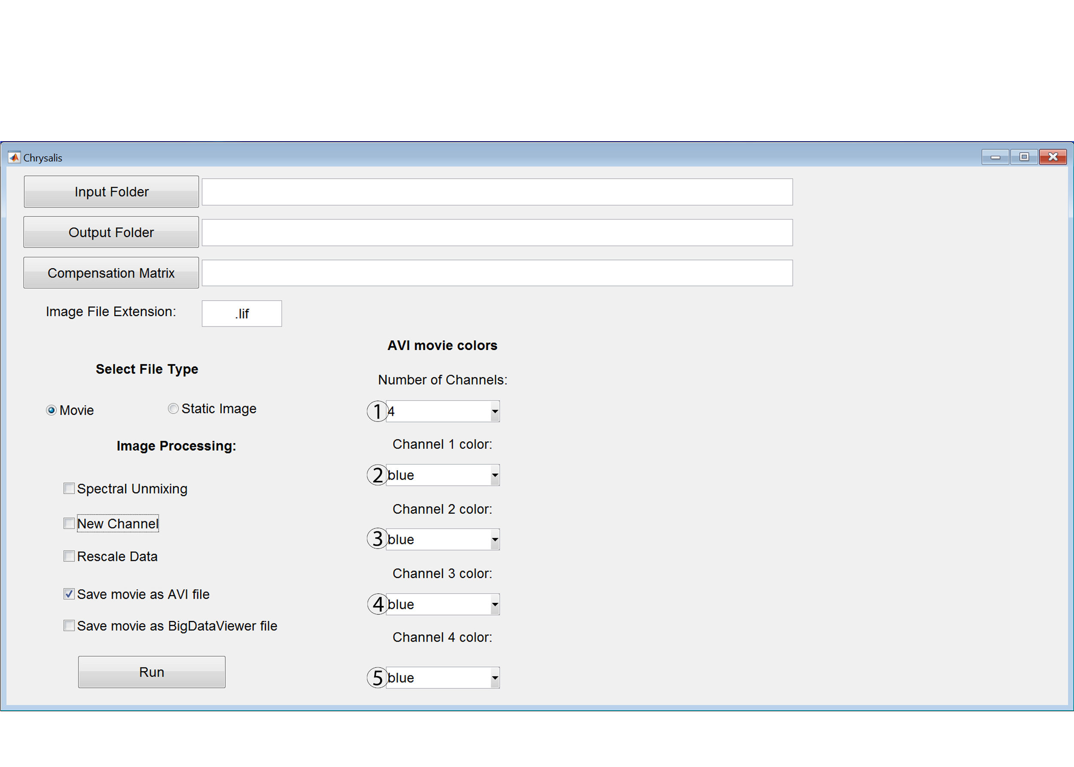

1. Use this dropdown menu to select the number of channels present in the movies that will be processed by Chrysalis. This feature can only be used on movies that have 4 or less channels.
2. Use this dropdown menu to select the color that will be used for channel 1 in the AVI movie.
3. Use this dropdown menu to select the color that will be used for channel 2 in the AVI movie.
4. Use this dropdown menu to select the color that will be used for channel 3 in the AVI movie.
5. Use this dropdown menu to select the color that will be used for channel 4 in the AVI movie.

**Features:**

Spectral Unmixing: Applies linear unmixing to the images based on values in the .sdm file selected as the compensation matrix.

New Channel: Generates a new channel that consists of only voxels that are above the threshold of the channels selected in the include menu and below the threshold of the channels selected in the exclude menu. The signal intensity for the voxels in the new channel is defined as the signal intensity of the user defined base channel. The base channel can be any of the channels in the image. For example, this feature can be used to create a new channel that only contains voxels for DCs by including channels for CD11c and MHCII while excluding channels for B220, F4/80, and CD3 and using CD11c as the base channel.

Multiple options can be selected in the listbox menu of the include and exclude channel menus by clicking control + left mouse button. To generate new channels, enter the number of desired channels that need to be generated into the “number of new channels” text box. Next, select between the new channels using the selected new channel menu. Each new channel can have unique settings (e.g. include, exclude, and base channel), except for the number of channels in the image (specified in the “Number of Channels” textbox), which needs to be the same for all of the new channels.

When entering values in the “Number of New Channels” and the “Number of Channels” boxes, the value must be a whole number typed as an integer rather than spelled out. For example, enter “1” rather than “one”.

Rescale Data: Rescaling the data is recommended to improve how images appear in Imaris. Rescaling will change the intensity values for each channel to utilize the entirety of the dynamic range. The changes in intensity values after rescaling make it difficult to compare images quantitatively in Flowjo, therefore the rescale factor for each image is exported alongside the image when this feature is selected. This rescale factor file can be used by the XTStatisticsExport and XTChrysalis Xtensions in Imaris to export normalized statistics for each image. This Xtension factors in the rescale factor that was initially applied during processing, thereby providing accurate image to image quantitative comparisons in Flowjo.

When analyzing movies:

Save movie as AVI file: This feature saves the movie as an AVI file. When this option is selected a window appears that allows for color selection for each channel. This option is great for quickly looking over movies to determine which movies have healthy tissue and are worth analyzing further.

Save movie as BigDataViewer file: This feature saves the analyzed movies as a BigDataViewer file, which can be directly opened in Imaris. If this option is not selected, then any spectral unmixing and new channel generation that was performed on the analyzed movies will not be saved.

When analyzing multispectral 3D images:

Merge all images in each file: If the file contains multiple images then selecting this feature will merge all of the images in the Z axis so they are stacked one after the other. This is a great option if a file contains multiple images from one tissue sample. Combining all of the images into one large image allows for the same analysis to be applied to all of the images from one tissue sample and expedites the analysis. Unlike traditional flow cytometry data, histo-cytometry analysis allows each cell to also be analyzed in Flowjo based on its position, cell shape, and distance to other cells.

**After Running the Chrysalis:**

Open the processed files in Imaris by selecting the h5 file for the image when using Imaris 9 or either the XML or h5 file for the image when using Imaris 8. It can take several minutes to open BigDataViewer files directly in Imaris, therefore it may be helpful to convert files into the .ims format with the Imaris fileconverter before opening the images in Imaris.

Upon opening the file in Imaris, the color of each channel can be changed and each channel can be labeled by selecting “image properties” under the “edit” tab.

Processing the images with Chrysalis will change the voxel size of the image leading to inaccurate distance measurements and surface generation. Therefore, while in “image properties”, change the voxel size for X, Y, and Z (found in image properties under the geometry tab) to the image’s original voxel size. The original voxel size can be found by opening the original Leica file in Leica’s LAS X software, right clicking the Leica file, and selecting “properties”. This approach does not work on merged files so use the non-merged version for finding the original voxel size. Upon changing the voxel size, the image might not be visible. In this case, click “fit” and “reset” in the bottom right hand corner of the Imaris window and the image should appear.

**If Matlab has a memory error in the middle of processing images:**

1. Make sure that all possible memory is allocated to Matlab by changing settings for java heap memory (In Matlab, click Preferences then select Matlab then General and then Java Heap Memory).

2. Close Matlab and restart the computer. Log back in and move any processed files out of the input folder specified in Chrysalis. Run Chrysalis again to continue processing files left in the input folder. Closing and opening Matlab without restarting does not always free up the memory.

**Sortomato V2.0**

Sortomato was created by Peter Beemiller. Sortomato V2.0 was generated by modifying the Sortomato Xtension to add hotkeys, additional features, bug fixes, and compatibility with Imaris 9.0.

**Added Hotkeys and Features:**

When in the Sortomato 2D graph for a selected surface there are a number of functions that are accessible by pressing keys on the keyboard (upper vs lowercase letters matters!). For all of these functions, it is necessary to first click off of the graph onto the background portion of the Sortomato 2D graph window before pushing any keys on the keyboard for these functions.

● h - Hides region labels and percentage

● H - Shows region labels and percentage

● e - edit selected region name. Whenever the name is edited, it will always have the shape of the region as the first four letters (e.g. a rectangular region will be “rect-name”). This is due to how the regions are utilized by Sortomato.

● s - Brings up a window to save the drawn regions, the X and Y axis and the limits for each axis. These can be loaded into another Sortomato 2D graph including between different Imaris files.

● o - Brings up a window to open a saved file that will apply regions, X and Y axis, and the limits for each axis to the current graph.

The copy and paste functions only work between Sortomato 2D graphs open in one instance of Matlab. It is only possible to use the copy and paste function within one Imaris file. Even if two Imaris files are open at the same time, it is not possible to copy and paste between them and the save (s) and open (o) functions need to be used instead.

● c - Copies the X and Y axis and the limits for each axis.

● C - Copies the regions, the X and Y axis and the limits for each axis.

● p - Pastes the X and Y axis and the limits for each axis.

● P - Pastes the regions, the X and Y axis and the limits for each axis.

**Other updates:**

● Sortomato now works with images that have more than 9 channels.

● It is now possible to have hundreds of objects in a surface, draw regions, and then create new surfaces from the regions.

● The Sortomato colors can be changed from white background and black letters to black numbers and white letters by changing the ‘w’ in line 66 of the Sortomato matlab file to ‘k’. The changed Sortomato file then needs to be saved on the desktop and dragged into the matlab folder in the Imaris directory in place of the existing Sortomato file. This was written in by Peter Beemiller and we used it to change to a white background.

● In the Sortomato 2D graph, the region selection window has been moved over and enlarged to allow longer region names to be fully visible.

● Percentages are calculated and displayed for each region.

● When saving regions drawn in Sortomato, the save file window that appears will automatically use the Imaris file’s name for the .mat region file name. The .mat name can still be edited in this save file window.

● Sortomato now works with Imaris 9. Specifically, the surface creation from regions drawn in Sortomato stopped working in Imaris 9 and we have changed the code for surfaces so that Sortomato can now create surfaces from regions drawn in Imaris 9. We have not tried Sortomato on spots or tracks in Imaris 9, so this issue may exist for using Sortomato on those objects in Imaris 9.

● When Imaris 8 and 9 were installed on the same computer, Sortomato would start using the Imaris 9 ImarsLib.jar for both Imaris versions which caused Sortomato to crash if Imaris 8 was being used for image analysis. This issue has been fixed so both Imaris versions can be installed on the same computer and the Sortomato will function properly for either version.

**Sortomato Window:**

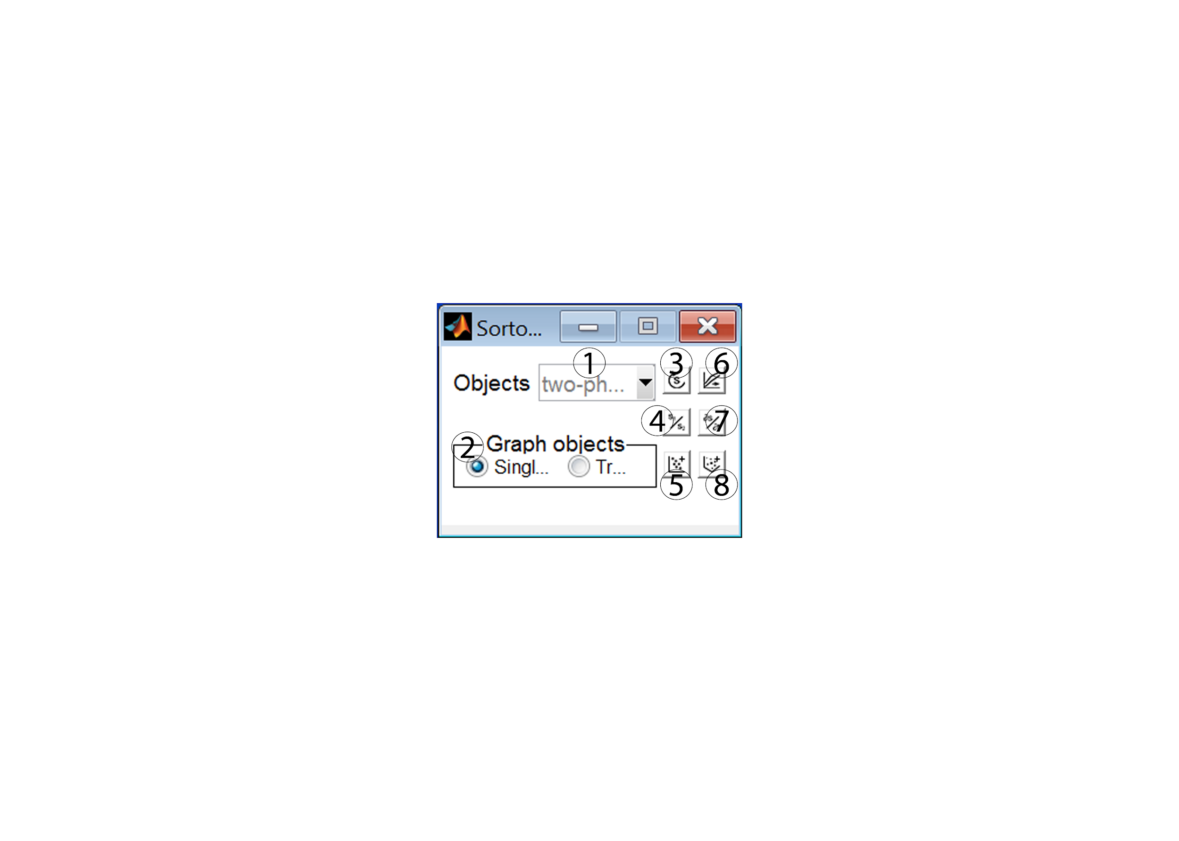

1. Dropdown menu to select surface for analysis.
2. Select to graph single objects or tracks.
3. Refresh the Surpass objects list.
4. Perform arithmetic using two statistics.
5. Graph selected object statistics (2D plot).
6. Export selected object statistics organized by track.
7. Calculate the derivatives of track statistics.
8. Graph selected object statistics in 3D.

**Sortomato 2D plot:**

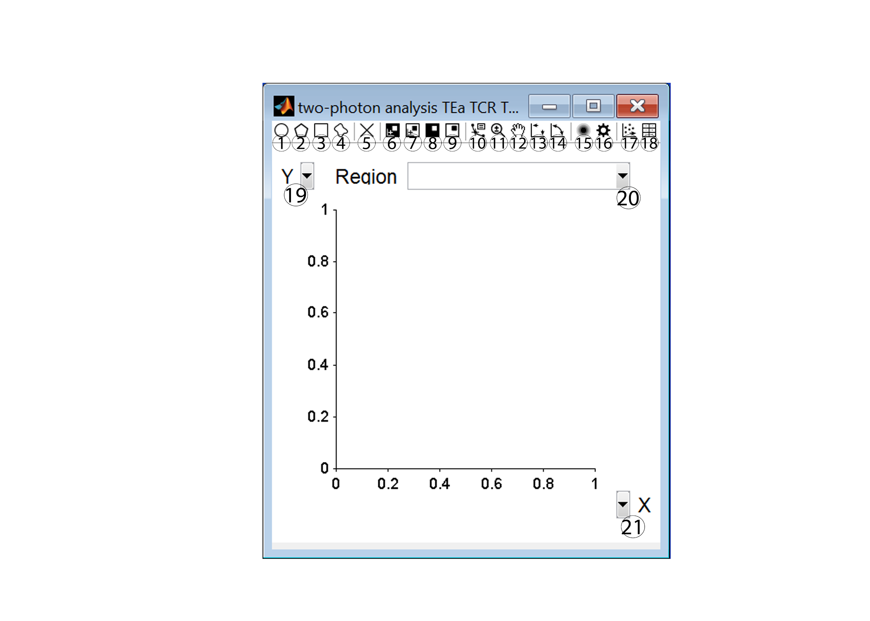

1. Create an ellipse region.
2. Create a polygon region.
3. Create a rectangle region.
4. Create a freehand region.
5. Delete the selected region.
6. Graph the objects inside the selected region.
7. Graph the objects outside the selected region.
8. Transfer the objects inside the selected region into a new Surpass object.
9. Transfer the objects outside the selected region into a new Surpass object.
10. Activate the data cursor.
11. Activate zooming.
12. Activate panning.
13. Set automatic or manual axes limits.
14. Swap the X and Y axis variables.
15. Switch to a contour plot.
16. Change contour settings.
17. Export the current graph.
18. Export the current graph statistics.
19. Define the variable for the Y axis.
20. Choose which region is selected.
21. Define the variable for the X axis.

**XTChrysalis/XTChrysalisImaris9 -** **Batched Surface generation from Sortomato Regions, Distance Transformation, Signal Intensity Rescaling and Statistics Export**

This Xtension will make a new surface for each of the regions in the Sortomato .mat file and then calculate the distance transformation for those new surfaces. This Xtension will also rescale the signal intensity for each channel before exporting statistics for every surface with “TCR” or “DC” in its name. Therefore, each surface needs to have TCR or DC in its name or the Xtension can be modified to identify surfaces that do not have TCR or DC in their name (described below). The exported statistics include intensity mean and minimum for each channel, as well as volume and position.

XTChrysalisImaris9 is the same Xtension as XTChrysalis with all of the same functions but with slight modifications to the code so that it is compatible with Imaris 9. If using Imaris 8, it is recommended to use XTChrysalis rather than XTChrysalisImaris9 because it will be faster.

**Prior to running this Xtension:**

Sortomato needs to be used on Imaris files to draw regions identifying the populations of interest for distance transformation. It is recommend to press ‘e’ to name each region because the region name will be the name of the new surfaces. These regions need to be saved for each file by pressing ‘s’ when in the Sortomato graph containing the drawn regions. The name of the saved file needs to be exactly the same as the corresponding Imaris file. Otherwise, XTChrysalis will not link the Imaris file to the drawn regions and will not be able to process the data. All of the Imaris files and their corresponding Sortomato region files need to be put into one folder.

Regions can be identified for different surfaces in a single Imaris file and batched for surface creation. The Sortomato graph for each surface will be saved by pressing ‘s’. The filename needs to be distinct between the multiple saved Sortomato graph files for each surface. The distinction is the addition of “_roi” followed by a number after the Imaris filename for each Sortomato graph file. For example, for an Imaris file named Mouse 1 with two Sortomato graph files, the Sortomato graph files will need to be named “Mouse 1_roi1.mat” and “Mouse 1_roi2.mat” (the .mat is added automatically upon saving).

It is also possible to subgate regions within a parent region and batch surface creation. When saving the regions, the parent region should be saved with the Imaris filename followed by “_roi” and a number. The daughter region of that parent should be saved with the Imaris filename followed by “_roi” then the number used for the parent and then any letter. For example, for an Imaris file named Mouse 1 with a parent region that is subgated in the Sortomato graph, the parent region will need to be named “Mouse 1_roi1.mat” while the Sortomato graph of the daughter region will need to be named “Mouse 1_roi1a.mat” (the .mat is added automatically upon saving). It is possible to have multiple daughter regions for a parent region, with each daughter region distinguished by different letters. For example, the first daughter would be named “Mouse 1_roi1a.mat” and the second daughter would be named “Mouse 1_roi1b.mat”.

Place the .mat and scalefactor.txt files generated by Chrysalis in the same folder containing all of the Imaris files that will have their statistics batch exported. The name of the Imaris file and its corresponding .mat and scalefactor.txt files must be exactly the same, excluding the .ims, .mat, or scaleFactors.txt at the end of the file name. For example, fileA.ims, fileA.mat and fileA.scaleFactors.txt need to be in the same folder for Sortomato region generation and rescaling to work. If the scaleFactor.txt file is not present in the folder, then the data will not be rescaled, but the statistics export should work just fine.

**Running the Xtension:**

Run the BatchProcess Xtension then select the folder containing the Imaris files, Sortomato region files, and rescalefactor files with the exact same name as their corresponding Imaris files. Next, select XTChrysalis.

The processed files are saved in g:/BitplaneBatchOutput. To change where the processed files are saved, edit the chrysalis.properties file (found in the BatchXTensions folder) so that the first line is changed from “outputPath = g:/BitplaneBatchOutput” to the file path for the new output folder (e.g. “outputPath = b:/XtensionsOutput”).

Currently, this script exports statistics for all surfaces with either “TCR” or “DC” in the name. Two statistics files are generated for each surface, one labeled “offset 0” and another labeled “offset 0.1”. The difference between the two different tables generated for each surface is that the offset 0.1 table has 0.1 added to each value so that there are no zero values, thereby allowing the data to be presented on a logarithmic plot in Flowjo.

Exporting statistics for other surfaces:

Change ‘TCR’ in lines 92 and 94 or ‘DC’ in lines 93 and 95 of XTChrysalis to a conserved portion of the name of the surfaces that will have their statistics exported. For example, if statistics should be exported for macrophage surfaces, then change the ‘TCR’ to ‘Macrophage’. Macrophage just needs to be a part of the surface name, but every Imaris file needs to have this conserved portion of the surface name. If a file does not have this conserved surface name, then CSV files will not be generated for that Imaris file. If these changes are made, make sure to change both lines (92 and 94 for changing TCR or 93 and 95 for changing DC). Alternatively, it is possible to add additional lines of code after line 95 to keep exporting TCR and DC surface statistics while adding more export parameters.

Here are the two new lines of code that need to be added for exporting statistics for macrophage surfaces:

saveTable(vImarisApplication, 'Macrophage', vNewFileName, offset);

saveTable(vImarisApplication, 'Macrophage', vNewFileName, 0);

The changed XTChrysalis file then needs to be saved on the desktop with a slightly altered name (e.g. XTChrysalisandMacrophage) and dragged into

C:/Program Files/Bitplane/BatchXTensions. When running BatchProcess, select the Xtension with the modified name.

**Image Rescaling:**

When Chrysalis rescales image files, the rescaling occurs on a channel by channel basis and is specific to each image file. Therefore if the images were rescaled in Chrysalis, but not normalized for the rescale during statistics export from Imaris, then quantitative comparison between images is not possible in Flowjo. This Xtension normalizes each image to account for the rescaling done by Chrysalis, thereby allowing quantitative comparison of images in Flowjo.

Rescaling only affects signal intensity for each channel, so images that have not been normalized for their rescaling can still be compared to other images based on distance measurements, volume, and cell position. However, signal intensity (like intensity mean or intensity minimum values) cannot be compared between non-normalized images.

For better visualization in Flowjo, every normalized statistic is multiplied by 1000. This multiplication occurs for every channel and image that is normalized, therefore normalized images can still be quantitatively compared to each other.

**XTCreateSurfaces - Batched Surface generation from Sortomato Regions**

XTCreateSurfaces batches the generation of new surfaces based on regions drawn in Sortomato. It is especially useful when trying to generate surfaces for regions drawn on hundreds of cells and in multiple Imaris files. While XTChrysalis also performs this function, XTCreateSurfaces does not calculate distances to the new surfaces and does not export statistics.

**Prior to running this Xtension:**

Sortomato needs to be used on Imaris files to draw regions identifying the populations of interest and generating new surfaces based on the regions. It is recommend to press ‘e’ to name each region because the region name will be the name of the new surface. These regions need to be saved for each file by pressing ‘s’ when in the Sortomato graph containing the drawn regions. The name of the saved file needs to be exactly the same as the corresponding Imaris file or the XTCreateSurfaces Xtension will not link the Imaris file to the region and will not be able to process the data. All of the Imaris files and their corresponding Sortomato region files need to be put into one folder.

Regions can be identified for different surfaces in a single Imaris file and batched for surface creation. The Sortomato graph for each surface will be saved by pressing ‘s’. The filename needs to be distinct between the multiple saved Sortomato graph files for each surface. The distinction is the addition of “_roi” followed by a number after the Imaris filename for each Sortomato graph file. For example, for an Imaris file named Mouse 1 with two Sortomato graph files, the Sortomato graph files will need to be named “Mouse 1_roi1.mat” and “Mouse 1_roi2.mat” (the .mat is added automatically upon saving).

It is also possible to subgate regions within a parent region and batch surface creation. When saving the regions, the parent region should be saved with the Imaris filename followed by “_roi” and a number. The daughter region of that parent should be saved with the Imaris filename followed by “_roi” then the number used for the parent and then any letter. For example, for an Imaris file named Mouse 1 with a parent region that is subgated in the Sortomato graph, the parent region will need to be named “Mouse 1_roi1.mat” while the Sortomato graph of the daughter region will need to be named “Mouse 1_roi1a.mat” (the .mat is added automatically upon saving). It is possible to have multiple daughter regions for a parent region, with each daughter region distinguished by different letters. For example, the first daughter would be named “Mouse 1_roi1a.mat” and the second daughter would be named “Mouse 1_roi1b.mat”.

**Running the Xtension:**

Run the BatchProcess Xtension then select the folder containing the Imaris files and Sortomato region files with the exact same name as their corresponding Imaris files. Next, select XTCreateSurfaces.

The processed files are saved in g:/BitplaneBatchOutput. To change where the processed files are saved, edit the chrysalis.properties file (found in the BatchXTensions folder) so that the first line is changed from “outputPath = g:/BitplaneBatchOutput” to the file path for the new output folder (e.g. “outputPath = b:/XtensionsOutput”).

**XTStatisticsExport - Rescale Data and Export Statistics**

XTStatisticsExport batches the export of statistics. Statistics will be exported for every surface in each image. The statistics that are exported include volume, area, position, and sphericity as well as mean intensity and minimum intensity for every channel. Two statistics files are generated for each surface, one labeled “offset 0” and another labeled “offset 0.1”. The difference between the two different tables generated for each surface is that the offset 0.1 table has 0.1 added to each value so that there are no zero values, thereby allowing the data to be presented on a logarithmic plot in Flowjo.

This Xtension also formats the exported data. For example, if the name for channel 1 is changed in Imaris to CD11c, then intensity mean for channel 1 will not be labeled “Intensity mean - Channel 1” but will instead be labeled “Intensity mean - CD11c.”

**Image Rescaling:**

When Chrysalis rescales image files, the rescaling occurs on a channel by channel basis and is specific to each image file. Therefore if the images were rescaled in Chrysalis, but not normalized for the rescale during statistics export from Imaris, then quantitative comparison between images is not possible in Flowjo. This Xtension normalizes each image to account for the rescaling done by Chrysalis thereby allowing quantitative comparison of images in Flowjo.

Rescaling only affects signal intensity for each channel, so images that have not been normalized for their rescaling can still be compared to other images based on distance measurements, volume, and cell position. However, signal intensity (like intensity mean or intensity minimum values) cannot be compared between these non-normalized images.

**Running the Xtension:**

Run the BatchProcess Xtension then select the folder containing the Imaris files and rescalefactor files with the exact same name as their corresponding Imaris files. Next, select XTStatisticsExport.

The processed files are saved in g:/BitplaneBatchOutput. To change where the processed files are saved, edit the chrysalis.properties file (found in the BatchXTensions folder) so that the first line is changed from “outputPath = g:/BitplaneBatchOutput” to the file path for the new output folder (e.g. “outputPath = b:/XtensionsOutput”).

**Image Rescaling:**

When Chrysalis rescales image files, the rescaling occurs on a channel by channel basis and is specific to each image file. Therefore if the images were rescaled in Chrysalis, but not normalized for the rescale during statistics export from Imaris, then quantitative comparison between images is not possible in Flowjo. This Xtension normalizes each image to account for the rescaling done by Chrysalis, thereby allowing quantitative comparison of images in Flowjo.

Rescaling only affects signal intensity for each channel, so images that have not been normalized for their rescaling can still be compared to other images based on distance measurements, volume, and cell position. However, signal intensity (like intensity mean or intensity minimum values) cannot be compared between non-normalized images.

For better visualization in Flowjo, every normalized statistic is multiplied by 1000. This multiplication occurs for every channel and image that is normalized, therefore normalized images can still be quantitatively compared to each other.

**Adding 0.1 to CSV files (addValueToAll_CSV.py)**

To obtain this script, please email the corresponding author.

This script is not necessary when using XTChrysalis or when using the ExportStatswithRescaleOffset Xtension because 0.1 is added to each value in the CSV files as part of those Xtensions. This script and its batchable version are for adding 0.1 to CSV files to eliminate any 0 values in the CSV file. Adding this small value allows all of the data to be plotted on a log scale once the CSV file is converted to a FCS file and opened in FlowJo. When the program is applied to a file, it will keep the original file while creating a new file that has ‘_plus01’ as a suffix.

Instructions for Mac:

● Make a folder for python scripts, in the user directory (where documents and applications folders are located).

● Add the addValueToAll_CSV.py and addValueToAllBatch_CSV.py scripts to the Python folder.

● Open terminal by going to the applications folder, then utilities folder, and open terminal.

● In the terminal window, type ‘cd Python’ (or cd the name of the folder containing the python scripts) to switch the directory to the folder containing the python scripts.

● Run the python script by typing in the following:

● For a single file type:

python ./addValueToAll_CSV.py "full path of the file of interest"

● For Batching type:

python ./addValueToAllBatch_CSV.py "full path of the folder of interest"*.csv

Tips:

● An easy way to copy a file’s path for pasting into the terminal window:

● Open a Finder window that contains the file or folder of interest

● Open a new finder window (command+N when a finder window is selected)

● Open the ‘go to folder window’ in the new finder window (shift+command+g)

● Drag file or folder of interest to the ‘go to folder window’ that appeared

● Copy the path in the ‘go to folder window’ (command+c)

● Adding a value other than 0.1

● Open addValueToAll_CSV.py or addValueToAllBatch_CSV.py in a text editor

● Change the ‘0.1’ to another value in the following line: v = float(element)+0.1

**Alternatives to the Chrysalis Software**

**Dye Separation:**

Saved matrices can be applied to images in the Leica Application Suite software. Apply the matrix to each image by selecting automatic dye separation under "Process” and select ‘manual’ to load the matrix. Set the rescale to per channel before applying the matrix to each image.

**Merging Images:**

Multiple images from a singular tissue that will be analyzed in the same manner, acquired with the same settings, and stained with the same panel on the same day can be combined for easier analysis. Multiple images cannot be merged simultaneously with either the Leica Application Suite or Imaris, hence the need to repeat this process to merge multiple images or use Chrysalis.

In Leica Application Suite:

Stack images for each panel/time point in the Leica Application Suite by selecting “Merge” under “Process” and selecting two images to stack together. Select ‘z’ for the parameter of the merge. Repeat this process for the other images but select the merged image for one and the additional image to be added to the stack as the second image to be merged.

In Imaris:

Images can be stacked in Imaris by clicking “add slices” under the edit tab. Select the lif file containing multiple images, then select settings to choose which image to merge with the already open image. For example, if image 1 is open, then select image 2 and click open.

**XTChrysalis2phtn -** **Batched Analysis of two-photon Microscopy Generated Movies including Distance Transformation, Cell-Cell Interaction Quantification, Signal Intensity Rescaling and Statistics Export**

This Xtension calculates the distance transformation for a surface with “DC” in its name and then quantify interactions between the “DC” surface and every surface with “TCR” in its name. These new statistics will be added to the “TCR” surfaces. Therefore, each surface needs to have TCR or DC in its name or the Xtension can be modified to identify surfaces that do not have TCR or DC in their name (described below). This Xtension will also rescale the signal intensity for each channel before exporting statistics for every surface with “TCR” or “DC” in its name. The exported statistics include intensity mean and minimum for each channel, as well as volume, position, and metrics describing cell-cell interaction like number of contacts.

**Prior to running this Xtension:**

Place the scalefactor.txt files generated by Chrysalis in the same folder that contains all of the Imaris files that will have their statistics batch exported. The name of the Imaris file and its corresponding scalefactor.txt files must be exactly the same, excluding the file format notation (.ims and scaleFactors.txt). For example, fileA.ims and fileA.scaleFactors.txt need to be in the same folder for rescaling to work. If scaleFactor.txt file is not available, then the data will not be rescaled, but the statistics export should work just fine.

**Running the Xtension:**

Run this Xtension by running the BatchProcess Xtension, then select the folder containing the Imaris files and rescalefactor files with the exact same name as their corresponding Imaris files. Next, select XTChrysalis2phtn.

The processed files are saved in g:/BitplaneBatchOutput. To change where the processed files are saved, edit the chrysalis.properties file (found in the BatchXTensions folder) so that the first line is changed from “outputPath = g:/BitplaneBatchOutput” to the file path for the new output folder (e.g. “outputPath = b:/XtensionsOutput”).

Statistics created by this Xtension for Tracks:

Track number of contacts with DC

Track number of prolonged contact events with DC

Track Percent Surface contact with DC

Track Total time in contact with DC

Track Total Time without Contact with DC

Track Longest contact event with DC

Track Mean Length contact event with DC

Statistics created by this Xtension for Tracks at each timepoint:

Distance to DC

Currently, this scripts exports statistics for all surfaces with either “TCR” or “DC” in the name. Two statistics files are generated for each surface, one labeled ‘offset 0’ and another labeled ‘offset 0.1’. The difference between the two different tables generated for each surface is that the offset 0.1 table has 0.1 added to each value so that there are no zero values thereby allowing the data to be presented on a logarithmic plot in Flowjo.

Exporting statistics for other surfaces:

Change ‘TCR’ in lines 89 and 91 or ‘DC’ in lines 90 and 92 of XTChrysalis2phtn to a conserved portion of the name of the surfaces that will have their statistics exported. For example, if statistics should be exported for macrophage surfaces, then change ‘TCR’ to ‘Macrophage’. Macrophage just needs to be a part of the surface name, but every Imaris file needs to have this conserved portion of the surface name. If a file does not have this conserved surface name, then CSV files will not be generated for that Imaris file. If these changes are made, make sure to change both lines (89 and 91 for changing TCR or 90 and 92 for changing DC). Alternatively, it is possible to add additional lines of code after line 92 to keep exporting TCR and DC surface statistics while adding more export parameters.

Here are the two new lines of code that need to be added for exporting statistics for macrophage surfaces:

saveTable(vImarisApplication, 'Macrophage', vNewFileName, offset);

saveTable(vImarisApplication, 'Macrophage', vNewFileName, 0);

The changed XTChrysalis2phtn file then needs to be saved on the desktop with an altered name (e.g. XTChrysalis2phtnandMacrophage) and dragged into

C:/Program Files/Bitplane/BatchXTensions. When running BatchProcess, select the Xtension with the modified name.

**Image Rescaling:**

When Chrysalis rescales image files, the rescaling occurs on a channel by channel basis and is specific to each image file. Therefore if the images were rescaled in Chrysalis, but not normalized for the rescale during statistics export from Imaris, then quantitative comparison between images is not possible in Flowjo. This Xtension normalizes each image to account for the rescaling done by Chrysalis thereby allowing quantitative comparison of images in Flowjo.

Rescaling only affects signal intensity for each channel, so images that have not been normalized for their rescaling can still be compared to other images based on distance measurements, volume, and cell position. However, signal intensity (like intensity mean or intensity minimum values) cannot be compared between these non-normalized images.

For better visualization in Flowjo, every normalized statistic is multiplied by 1000. This multiplication occurs for every channel and image that is normalized, therefore normalized images can still be quantitatively compared to each other.

**XTMovieSurfacesAndStats -** **Batched Surface generation from Sortomato Regions, Distance Transformation, Signal Intensity Rescaling and Statistics Export**

This Xtension will make a new surface for each of the regions in the Sortomato .mat file and then calculate the distance transformation for those new surfaces. This Xtension will also rescale the signal intensity for each channel before exporting statistics for every surface with “TCR” or “DC” in its name. Therefore, each surface needs to have TCR or DC in its name or the Xtension can be modified to identify surfaces that do not have TCR or DC in their name (described below). The exported statistics include intensity mean and minimum for each channel, as well as volume and position.

**Prior to running this Xtension:**

Sortomato needs to be used on Imaris files to draw regions identifying the populations of interest for distance transformation. It is recommend to press ‘e’ to name each region because the region name will be the name of the new surfaces. These regions need to be saved for each file by pressing ‘s’ when in the Sortomato graph containing the drawn regions. The name of the saved file needs to be exactly the same as the corresponding Imaris file. Otherwise, XTMovieSurfacesAndStats will not link the Imaris file to the drawn regions and will not be able to process the data. All of the Imaris files and their corresponding Sortomato region files need to be put into one folder.

Regions can be identified for different surfaces in a single Imaris file and batched for surface creation. The Sortomato graph for each surface will be saved by pressing ‘s’. The filename needs to be distinct between the multiple saved Sortomato graph files for each surface. The distinction is the addition of “_roi” followed by a number after the Imaris filename for each Sortomato graph file. For example, for an Imaris file named Mouse 1 with two Sortomato graph files, the Sortomato graph files will need to be named “Mouse 1_roi1.mat” and “Mouse 1_roi2.mat” (the .mat is added automatically upon saving).

Place the .mat and scalefactor.txt files generated by Chrysalis in the same folder containing all of the Imaris files that will have their statistics batch exported. The name of the Imaris file and its corresponding .mat and scalefactor.txt files must be exactly the same, excluding the .ims, .mat, or scaleFactors.txt at the end of the file name. For example, fileA.ims, fileA.mat and fileA.scaleFactors.txt need to be in the same folder for Sortomato region generation and rescaling to work. If the scaleFactor.txt file is not present in the folder, then the data will not be rescaled, but the statistics export should work just fine.

**Running the Xtension:**

Run the BatchProcess Xtension then select the folder containing the Imaris files, Sortomato region files, and rescalefactor files with the exact same name as their corresponding Imaris files. Next, select XTMovieSurfacesAndStats.

The processed files are saved in g:/BitplaneBatchOutput. To change where the processed files are saved, edit the chrysalis.properties file (found in the BatchXTensions folder) so that the first line is changed from “outputPath = g:/BitplaneBatchOutput” to the file path for the new output folder (e.g. “outputPath = b:/XtensionsOutput”).

Currently, this script exports statistics for all surfaces with either “TCR” or “DC” in the name. Two statistics files are generated for each surface, one labeled “offset 0” and another labeled “offset 0.1”. The difference between the two different tables generated for each surface is that the offset 0.1 table has 0.1 added to each value so that there are no zero values, thereby allowing the data to be presented on a logarithmic plot in Flowjo.

Currently, this script exports the average statistics (like micron/min) for each cell with each row in the CSV file corresponding to one track. In the future, this Xtension will also generate a folder for each surface within the output folder (‘g:/BitplaneBatchOutput’) which will contain a separate CSV file for each track that depicts measurements for that track over the course of the movie with each row corresponding to a different time. This new folder will also contain one master CSV file that will have each track at each time point combined into one large CSV file.

Changing which surface has its statistics exported:

Change ‘TCR’ in lines 30, 32, 35, 37 or ‘DC’ in lines 31, 33, 36, 38 of XTMovieSurfacesAndStats to a conserved portion of the name of the surfaces you want to get the statistics for. For example, if I want to export statistics for macrophage surfaces then I would change the ‘TCR’ to ‘Macrophage’. This does not need to be the entire name of the surfaces, but every Imaris file needs to have this conserved portion of the surface name and if a file does not have this conserved named surface then CSV files will not be generated for that Imaris file (it might also crash the Xtension, but I have never tried). If you are changing TCR or DC, make sure to change all of the corresponding lines. Alternatively, you can add additional lines of code after line 38 if you want to keep TCR and DC surface statistics export while adding more export parameters. If you want to add export of macrophage surfaces then the two new lines of code should be the following:

saveTable(vImarisApplication, 'Macrophage', vNewFileName, offset);

saveTable(vImarisApplication, 'Macrophage', vNewFileName, 0);

The changed XTMovieSurfacesAndStats file then needs to be saved on the desktop with a slightly altered name like XTMovieSurfacesAndStatsAndMacrophage and dragged into

C:/Program Files/Bitplane/BatchXTensions. When running BatchProcess, select the XT with the modified name.

**Image Rescaling:**

When Chrysalis rescales image files, the rescaling occurs on a channel by channel basis and is specific to each image file. Therefore if the images were rescaled in Chrysalis, but not normalized for the rescale during statistics export from Imaris, then quantitative comparison between images is not possible in Flowjo. This Xtension normalizes each image to account for the rescaling done by Chrysalis, thereby allowing quantitative comparison of images in Flowjo.

Rescaling only affects signal intensity for each channel, so images that have not been normalized for their rescaling can still be compared to other images based on distance measurements, volume, and cell position. However, signal intensity (like intensity mean or intensity minimum values) cannot be compared between non-normalized images.

For better visualization in Flowjo, every normalized statistic is multiplied by 1000. This multiplication occurs for every channel and image that is normalized, therefore normalized images can still be quantitatively compared to each other.